Figure List
PartⅠ

Chapter 5 Ground Improvement with Grouting type admixture

Fig. 5.1 Grouting Type with Admixture
Fig. 5.2 Layout of Grouting System
Fig. 5.3 Types of Materials used as Grout
Fig. 5.4 Pattern of Injected Zone
Fig. 5.5 Compaction Grouting
Fig. 5.6 Procedure Types of Permeation Grouting
Fig. 5.7 Mechanism of Permeation Grouting Pippe
Fig. 5.8 Confluence Point of Grout Solution and Gel-time
Fig. 5.9 Relation of Soil Type, Injection Pattern and Grout
Fig. 5.10 Family of Jet grouting system (JGA, 2012)
Fig. 5.11 Single Pipe system (Nakanishi & Nakazawa, 2006)
Fig. 5.12 Double Pipe system (Nakanishi & Nakazawa, 2006)
Fig. 5.13 Triple Pipe system (JAFEC, 2014)
Fig. 5.14 Procedures of Double Pipe system (JAFEC 2014)
Fig. 5.15 Applications of Jet-grouting method (JAFEC 2014)
Fig. 5.16 Relationship between Unconfined compressive strength and Total water content
Fig. 5.17 Example of Mixing shaft
Fig. 5.18 Construction Procedure of DMM
Fig. 5.19 Installation patterns of Solidified mass by DMM
Fig. 5.20 Typical applications of DMM

Grouting by admixtures
Permeation and chemical grouting
Jet grouting
Deep mixing

(a) Category and Method of Grouting

Deep
Mixing
Grouting
Jet
Grouting

High Strength
Medium Strength
Low Strength
(MN/ m²)
10
1
0.1

(b) Expected improvement effect
Fig. 5.1 Grouting type with admixtures (JAFEC, 2010)
(Hatchingを入れる)

Mixing Point 2
Grout Mixer

Boring Machine
Swivel
Grout Hose

Mixing Point 1
Flow Meter

Boring & Injection Pipe
Grouted Zone
Injection Tip
Grout Pump
Mixing Point 3

Fig. 5.2 Layout of Grouting System (Modified from JGA, 2017)

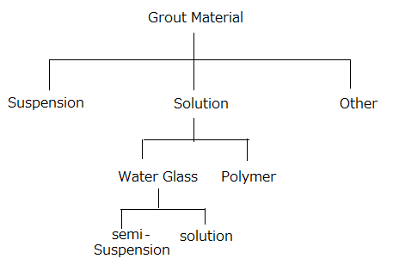
Grout Material

Other
Solution
Suspension

Water Glass
Polymer

Solution
Semi-suspension

Fig. 5.3 Types of Materials used as Grout (JGA, 2017)

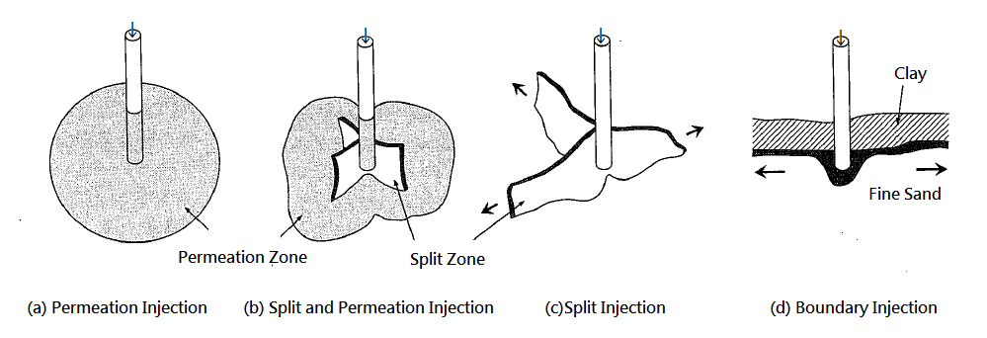
Fig. 5.4 Pattern of injected zone (JGS, 2009)

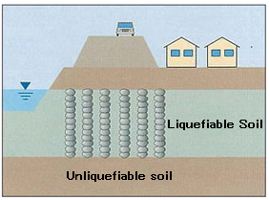
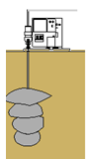

Liquefiable Zone
Non-liquefiable Zone

Fig. 5.5 Compaction grouting (JAFEC, 2010)
（書き直す：学生へ）

Permeation Grouting

Synchronous
Multi-points
(Multi-bundle tube)
Single Pipe
Double Pipe
Strainer Type
Double
Packer Type
Pipe with
Strainers
Simple Pipe

Twin Phase
Single Phase

Fig. 5.6 Procedures of permeation grouting

B
A
A
B
B
A

A + B
(Flash setting)

B
B
A
B
A
B
A + B

A + B
(Slow setting)

A + B
A + B
A + B

(a) Single Pipe (With Strainer) (b) Double Pipe (With Strainer) (c) Double Pipe (With strainer)
(Single Phase) (Twin phase)
Seal grout
Grout
Grout
Multi tube
Grout
Packer

(d) Double Pipe (Double Packer) (e) Synchronous Multi-points
Figure 5.7 Mechanism of Permeation Grouting Pipe (Modified from Shibazaki, 1984).

(a) One-shot process (Gel-time: slower)

Confluence point
A,b,c
（直しました：もう少し改善が必要）

(b) One-half-shot process (Gel-time: intermediate)

Tip

Confluence point 〇

(c) Two-shot process (Gel-time: faster)

Fig. 5.8 Confluence Point of Grout Solutions and Gel-time (JGA, 2017)

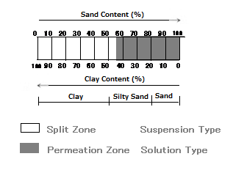

Soil type | Injected Pattern | Suitable Materials
Sand 65 % over  Sand 35 % under  Clay 35 % over  Clay 35 % under | Permeating  Splitting  Splitting  Permeating | Solution  Suspension  Suspension  Solution

Fig. 5.9 Relation of soil type, Injected Pattern and Grout (JGS, 2009)
（スキャンをし直し：学生へ）

Single pipe system
Jet Grouting

Double pipe system

Triple pipe system

Fig. 5.10 Family of Jet grouting system (JGA, 2012)

Drilling water
at low pressure
Jetting Grout
at high pressure

Drilling bit
Deferential pressure valve

Nozzle
Spring
Jetting Grout
at high pressure

Fig. 5.11 Single Pipe system (Nakanishi & Nakazawa, 2006)

Air
Grout
Air

(Drilling water at pre-jetting)
(Ball valve falls down
at grout-jetting)
Drilling bit
Jetting air
Jetting grout
Nozzle
Ball valve

Fig.5.12 Double Pipe system (Nakanishi & Nakazawa, 2006)

Water
Grout
Air
Grout
Air

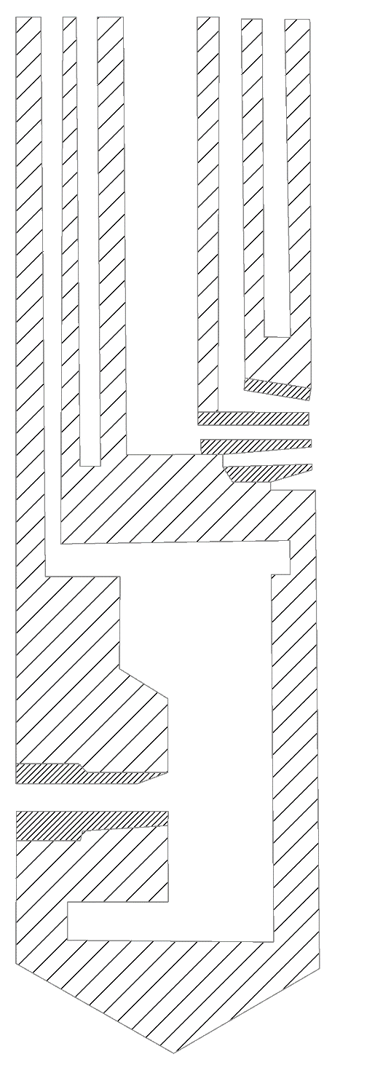
Jetting grout
Head shoe
Nozzle
Nozzle
Jetting air
Jetting air
Jetting water
Fig. 5.13 Triple Pipe system (JAFEC, 2014)

Fig5.3.5(Fig.5.14)を挿入すること？

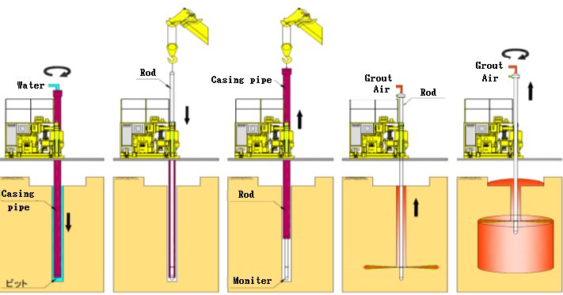
(Fig.5.14)
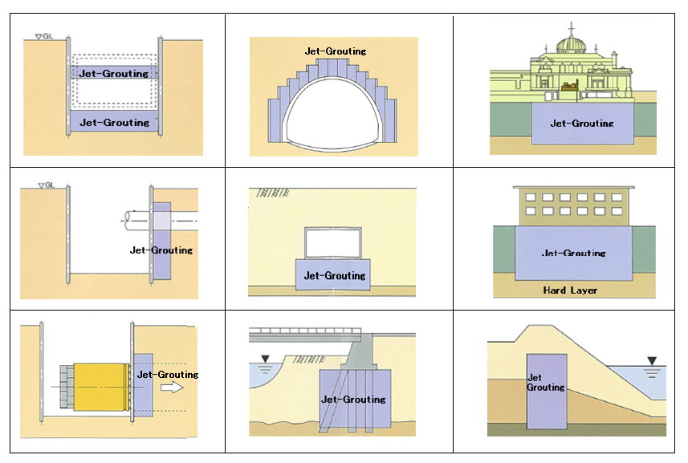

Fig. 5.15 Applications of Jet-grouting method (JAFEC 2014)

Rewrite
Fig. 5.16 Relationship between unconfined compressive strength and total water content (Babasaki et al., 1996).

1kgN/cm2=100kPa
80kgN/cm2=8MPa
（書き直す；学生へ）

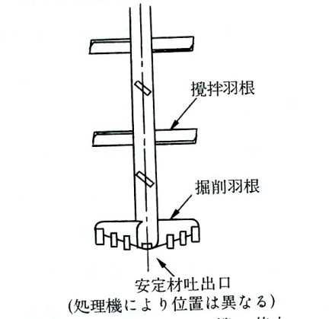
Mixing blade
Discharging outlet for solidifying material
Drilling blade
Fig. 5.17 Example of mixing shaft (Saito, 1991).
（書き直す：学生へ）

5
4
3
2
1

1) Positioning of auger tool
2) Drilling and mixing soil with cement grout
3) Bottom mixing
4) Withdrawing while continuing soil mixing
5) Completion mixed column
Fig. 5.18 Construction procedure of DMM（Catalogue of JAFEC/ AOMI group）
(イメージを書く直す：学生へ)

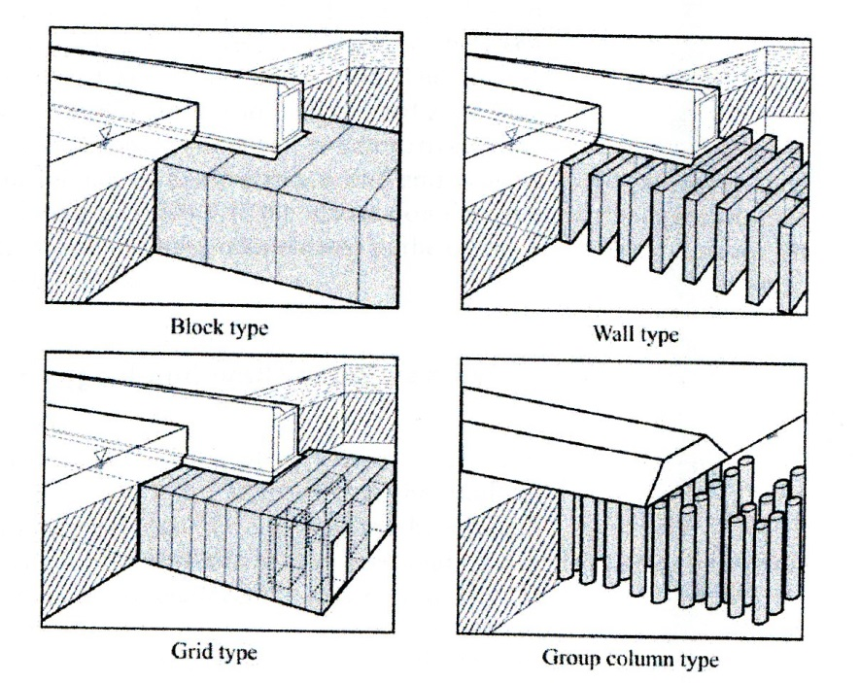
(d)
(c)
(b)
(a)
Fig. 5.19 Installation patterns of solidified mass using DMM(Kitazume & Terashi, 2017）

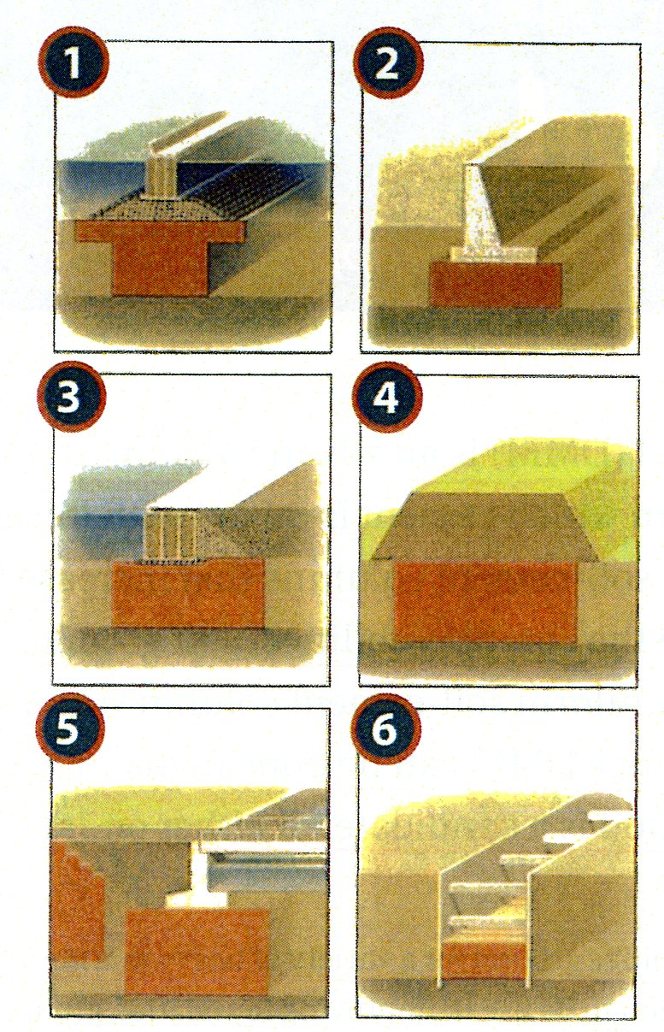
Fig. 5.20 Typical applications of DMM (Catalogue of JAFEC/ AOMI group)
（書く直す：学生へ）

